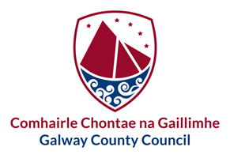
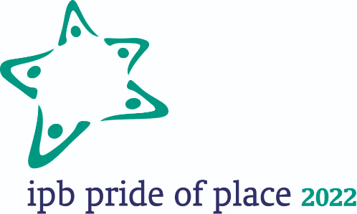
Pride of Place Awards 2022

Guidelines

Introduction:
Pride of Place, described as the “Oscars of the Community Sector” is an All-Island Competition which acknowledges and celebrates the work that communities are doing all over the island of Ireland. The annual awards programme is run by Co-operation Ireland in conjunction with local authorities North and South, and its headline sponsor is IPB Insurance.

Entry to the Competition is by way of local authority nomination only and Galway County Council is now inviting Expressions of Interest from local communities who wish to seek nomination to the National IPB Pride of Place Competition 2022.

Entry Categories:
Pride of Place is about recognizing improvements made by local communities to create civic pride in their local area by working together to improve amenities, activities, facilities, and the character of their area in a way that generates awareness, respect, and inclusion for every sector of their community. Therefore, what is most important in your submission is showing how you take a whole-of-community approach to the development of your local area.
- All previous Category Winners may be viewed at https://prideofplace.ie/
- Note: As Galway County Council may make nominations to the National Pride of Place Competition on a town/village basis, applications received from different groups in the same town/village may be judged as one.

Application and Judging Process:
The application and judging process is as follows:
- Expressions of Interest must be made via a one-page typed summary on the Expression of Interest Form and submitted by e-mail to awards@galwaycoco.ie on or before the local closing date of Friday 6th May 2022.
- The Expressions of Interest will be assessed internally in accordance with the national judging criteria and 2 County Galway Pride of Place winners will be selected.
- The County Galway Pride of Place winners will be entered into the national competition by the national closing date of 13th May and further detail on their entry will be submitted before the next stage of the process closes on 10th June.
- The IPB Pride of Place judging season takes place from July-August and may take the form of an in-person presentation and tour, or a presentation and interview via zoom.
- The Council will nominate a Pride of Place Liaison Officer who will assist the County Galway Pride of Place winners with the application and judging processes.

Awards Process:
- Local Winners will receive a cash prize of €1,000 towards their work and/or expenses related to entering the competition and attending the Award Ceremony.
- National Winners, runners-up and special award recipients will receive a trophy and a small monetary prize at a national awards ceremony (this is normally held annually in November but due to delays in the 2020 and 2021 competitions, it is likely to be held in early 2023).

Pride of Place Awards 2022

Expression of Interest Form

Village/Town/Area in County Galway being represented:
Name of Lead Applicant Group / Organisation:

Category under which application is being made: ** | 0-300 Population ☐ Creative Place ☐  300-1000 Population ☐ Community Resilience ☐  1000-2000 Population ☐ Community Tourism Initiative ☐  2000-5000 Population ☐ Community Wellbeing Initiative ☐ Over 5000 Population ☐  Housing Estates ☐  Islands and Coastal Communities ☐  Urban Neighbourhoods ☐  Please tick one box only
List all Community & Voluntary Groups, Businesses, Schools, etc., involved in making this application:

**Note: there will be a Special Award for Climate Action from 2022 to reward excellence in environmental response to current climate changes. As it is a universal theme across all categories and a question on the submission form and judging criteria, there is no separate application form, and a national winner will be selected from the applicants across all categories.

Declaration of Contact Person for Lead Applicant Group:
I declare that the information given in this form is true and complete to the best of our knowledge and all parties listed above are willing to represent our Town/Village/Project in the National Pride of Place Competition if they are successful in attaining the County Galway Pride of Place Award.
Name:
Role in Lead Applicant Group/Organisation:

Mobile Phone No:

Your Pride of Place Submission:
Please input your submission under the following questions and note:
- The maximum size of a submission is this one-page typed summary which should be written as full sentences/paragraphs (avoid the use of lists or bullet points).
- Your submission should be written in the third person and avoid the use of any name, persons, or personalities – see description of previous winners at https://prideofplace.ie/

Describe your area or initiative and achievements/activities to date which have had an impact on your local area.

What values do you hold as an area/initiative and what are you most proud of?

Describe how you reach out and collaborate with other groups and the wider community in your area.

Describe any plans for the future development of your area/initiative and how you will ensure its sustainability.

